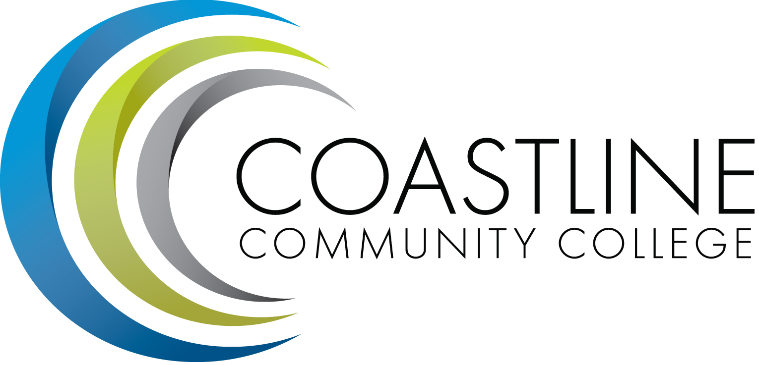

Budget Committee DRAFT
Wednesday, September 13, 2017 CANCELLED
1:00 p.m. – 3:00 p.m. 9/13/17
College Center – Fourth Floor Conference Room

Committee Mandate: To identify resource allocation based on the mission, plans, and goals of the college as articulated in the Education Master Plan (EMP) and as developed and recommended by the Planning, Institutional Effectiveness and Accreditation (PIEAC) committee.

CALL TO ORDER
  - Welcome
  - Adoption of Agenda
  - Approval of Minutes: March 22, 2017
  - Review the Charge and Mandate of the Budget Committee – C. Nguyen

REPORTS
  - 2017-2018 Adopted District Budget Summary – A. Dunn
  - Budget Committee Survey Results – A. Zentner
  - Enrollment Report – V. Rodriguez
  - 2016-2017 College ending Balance Report – C. Nguyen

DISCUSSION
3.1 2017-2018 PIEAC Funding Requests – C. Nguyen

ACTION

STANDING REPORTS

ANNOUNCEMENTS
6.1 Next Meeting: November 8, 2017

ADJOURNMENT

Attachment provided via email and at meeting

